MECH 325

**Team Assignment #2**

Team E4

horizontal line

# 

Source: https://rockthebike.com/fender-blender-pro/

# **Team E4:**

Amran Osman

Friend Prakitpong

Gianni Co

Hassan Iqbal

Husein Alatas

Ricky Asfour

Steven McCulloch

## **Introduction**

We have decided to design a chain drive for a bike-powered electric blender, and we will specify other relevant components to the system. This Idea was mainly inspired by a youtube video a team member recommended during a meeting.

**Key features**

* Make your favorite smoothies, shakes, margaritas, or baby food while exercising
* Strong enough to crush vegetables, fruits, and ice easily
* Can even be used by kids
* Totally human-powered
* Zero emissions and minimal noise

## **General approach**

For the purpose of the project, the team decided to specify the chain, sprockets, bike front-tire, transmission roller, and the blender. The general approach is outlined in the following list:

1. Specify the average and maximum Input power into the system based on typical cyclist data.
2. Specify the typical cadence rate of a bicycle driver and specify the RPM and power input of the blender.
3. Find the gear ratio between the driving and driven sprockets and between the bike tire and the transmission roller.
4. Find the number of teeth of the driving and driven sprockets and find the diameters of the bike wheel and the transmission roller.
5. Find the required contact area between the bike tire and the transmission roller to achieve a no-slip condition.
6. Specify the needed height of the transmission roller based on the found diameter and contact area.
7. Specify the chain using the method outlined in Shigley 10th edition Page 902-907.
8. Specify how to connect roller to the blender jar.

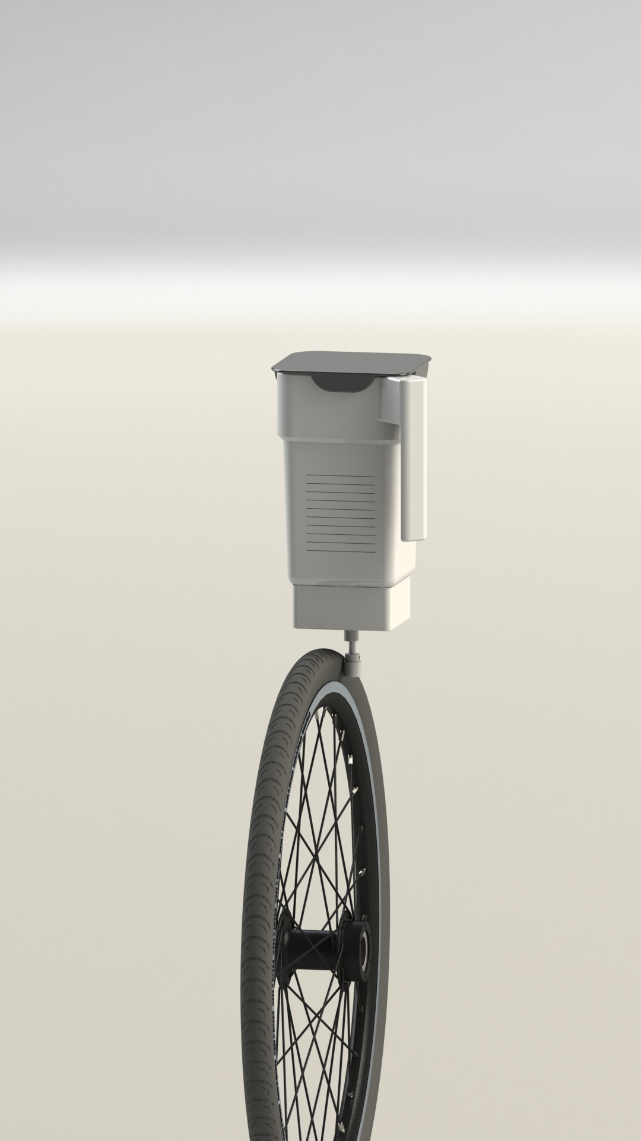

# **Assumptions and Notes**

The calculations performed in this report are based on the Shigley 10th edition textbook.

### **Assumptions**

* No slipping between the tire and the rollers
* No slipping between the sprocket and rollers
* No chordal speed variation with respect to the bike chains

### **Key Parameters**

Pave= 100W = 0.134 Hp

Average human power output while cycling

Vave= 100 rpm

Average cadence for low torque bike exercise

Pmax= 480W = 0.650 Hp

Peak power output of olympic cyclist

Pb= 300W = 0.402 Hp

Smallest power rating for a blender

Vb 12500 rpm

Lowest speed of 300W blender

eneeded= 1:125

“Gear” ratio derived from output speed/input speed

Ns= 32 teeth

Largest bike sprocket we could find

Ns= 11 teeth (smaller sprocket)

Smallest bike sprocket we could find

Sprockets - 11:32 = 1:2.909

Gear ratio of sprockets

eremaining = 125/2.909 = 1:43

The remaining gear ratio that will be facilitated by the tire and roller

Dtire= 27.6 in

Largest diameter bike tire we could find

Droller = 27.6/43 = 0.64 in ~ ⅝ in

Roller diameter that will satisfy the gear ratio

Ks = 1.3

Service factor chosen for moderate shock

Nd = 1.5

Design factor chosen because input power unlikely to exceed 100W

C = 16.5 in

Typical center-center distance for bike chains

Source:https://www.rivbike.com/pages/why-the-long-stays-chainstay-length

### **Bill of Materials**

|  |  |  |  |  |  |
| --- | --- | --- | --- | --- | --- |
| **Product Name** | **Part Name** | **Quantity** | **Supplier/Vendor** | **Unit cost ($CAD)** | **Total cost ($CAD)** |
| Rotary Shaft  303 Stainless Steel, 1/8" Diameter, 4" Long | Shaft | 1 | McMaster-Carr | 4.85 | 4.85 |
| Neoprene Roller  Drive, Aluminum Hub, 5/8" Roller Diameter, 1/2" Roller Width | Drive roller | 1 | McMaster-Carr | 28.90 | 28.90 |
| 32 Tooth Rear Sprocket | Large sprocket | 1 | BikeBerry.com | 19.07 | 19.07 |
| Walmeck Bike Cassette Cog MTB Road Bike Freewheel Sprocket Cycling Bicycle Cassette Fixed Gear | Small sprocket | 1 | Amazon.ca | 6.69 | 6.69 |
| Economy Plus #40 Roller Chain - 10ft Box | Chain | 1 | USA roller chains % sprockets | 16.90 | 16.90 |
| Blendin Complete 64oz Replacement Jar Container Set, Compatible with Vitamix Blenders | Blender jar | 1 | Amazon.ca | 54.99 | 54.99 |
| Drive Socket Replacement Kit with Wrench Compatible for Vitamix Blenders Spare Parts Tool | Blender socket | 1 | Amazon.ca | 14.29 | 14.29 |
| Stainless Steel Ball Bearing  Shielded, Trade Number R144-2Z | Ball bearing | 1 | McMaster-Carr | 7.19 | 7.19 |

### 

### **Additional Notes**

Wheel diam https://www.biketiresdirect.com/common-tire-sizes-article

Friction coefficient https://www.engineeringtoolbox.com/friction-coefficients-d_778.html

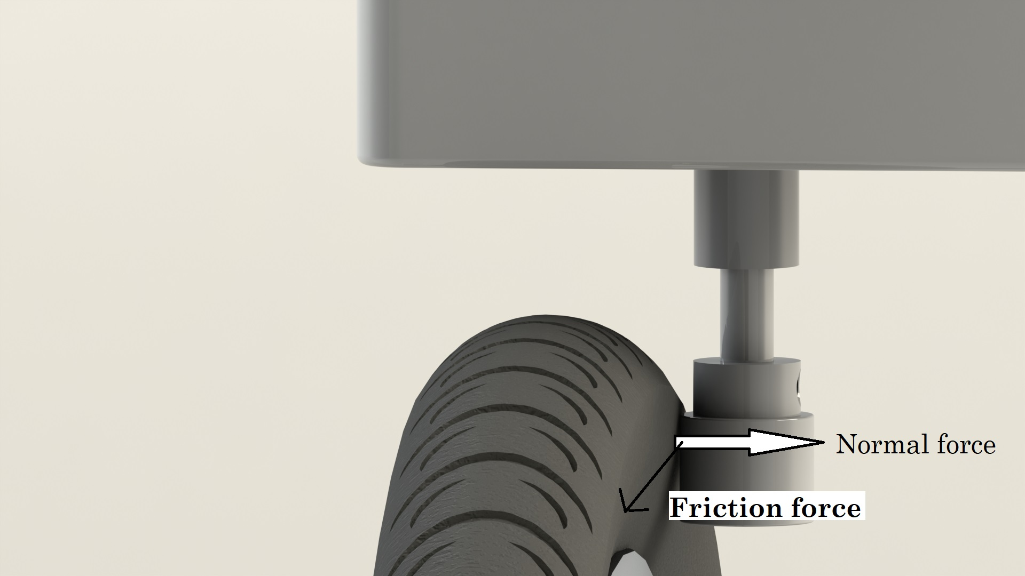

### 

## **Safety Factor:**

The safety factor was incorporated by designing for the max power professional cyclists can provide instead of the average power. This gave a tabulated power after conversion to 0.49 Hp. As an additional safety the ANSI 40 chain and sprocket were used which have capacity of 0.69 Hp.

## 

## **Appendix I - Chain Calculations**

# **Ks**=1.3 (moderate shock)

# **Nd**=1.5 (input power unlikely to be >100 watts)

# **Hnom**=0.65 (for max power input)

# **K1**=2.583 (for 32 sprocket- Pre extreme)

# **K2**= 1 ( 1 strand)

# **Htab**= (KsndHnom)/(K1K2)

= 0.491 Hp

Hence use ANSI Chain Number 40 with capacity of 0.69 Hp at 100 rpm.

**P**= 0.5

**N1**=32

**N2**=11

**C**=16.5 in

L/P=(2C/P)+ (N1+N2)/2 +((N2-N1)2/(4pi2C/p) = 44 inches rounded off

Length of chain required is 44 inches or 3.66 ft.

# 

# 

# 

# 

# **Appendix II - Friction calculation**

The transmission of torque from the tire to the roller is supplied by the friction between them. To allow for this transmission, there needs to be sufficient normal force on the roller from the tire. This can be done by fixing the roller in a position where it contacts the tire. The normal force can be found by using the tire pressure and the contact area of the roller on the tire. The condition for no slipping is for the friction force to be greater than the driving force. The friction force is equal to friction coefficient * normal force. The static friction coefficient of rubber on rubber was used. Although neoprene would have a higher static friction coefficient, we need to use the kinetic coefficient friction so we assumed the these two factors to cancel out.

|  |  |  |
| --- | --- | --- |
| **Parameter** | **Value** | **Source** |
| Tire pressure (psi) | 30 | research |
| Tire pressure (kPa) | 207 |
| Coefficient of friction | 1.16 | research |
| Roller contact width (in) | 0.5 | supplier |
| Roller contact length (in) | 0.5 | calculated |
| Speed (rpm) | 12500 | research |
| Power (W) | 100 | research |
| Torque (Nm) | 0.0764 | calculated |
| Tire radius (m) | 0.35 | research |
| Driving force (N) | 0.2183 | calculated |
| Friction force (N) | 38.7290 | calculated |

As for connecting the roller to the blender jar, we will use a ball bearing on the roller with a shaft attached to both the ball bearing and the blender socket. The blender socket fits on square shafts, so the round shaft will have to be machined to have a square tip. The blender jar will fit onto the blender socket. There will be a plastic base where the blender socket is attached, the roller is attached at the bottom and held in place. The base can be attached to the front or the back of the bike frame.